Lancashire Conservation Studios  Lancashire Museums  Examination Report |  | 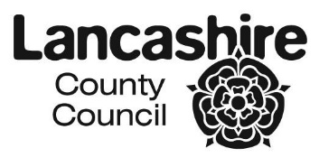
Client: | Cumbria's Museum of Military Life  Alma Block  The Castle  Carlisle CA3 8UR
Contact: | Nick Hazelwood
Subject: | “Soldiers of the 34th & French Zouaves playing skittles in the camp before Sebastopol, Crimea, 1855 (Painted 1861)
Artist: | Paul Alexandre Protais, 1826-1890
Accession No: | CALBR3020
Dimensions: | Painting: Height: 1000mm x Width: 1660mm
Notes on Condition
The painting was examined in a store room at Cumbria's Museum of Military Life.
It had been placed face up on a table and the frame was stored separately. The painting is in a very fragile condition and cannot be stored vertically. The frame no longer offers the painting any structural support. They both require urgent treatment.

Frame: the frame has a very simple profile. It is made from a light soft wood. The surface decorative coating gives the frame a distressed, aged look. There are numerous marks of mechanical damage around the edges of the frame. The frame mitres have been damaged and have opened up. The frame is, therefore unstable and cannot support the weight of the painting. The glue in the mitred corner joint has failed and the shafts of the nails can be seen within the gap created by the opening of the mitres.

Stretcher: the secondary support is a wooden stretcher made from pine. It has tongue and groove butt-joints and a central cross piece. All elements of the stretcher can be keyed out with tensioning wedges. It was not possible to see how many of the original wedges remained. The stretcher is soiled and has several chalk inscriptions on the reverse. The lining canvas edges are adhered to the back of the stretcher with animal glue. The stretcher is structurally sound and could be reused.

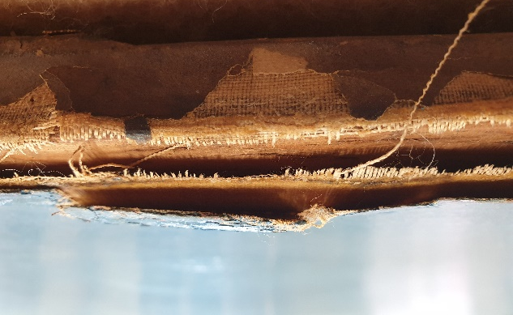
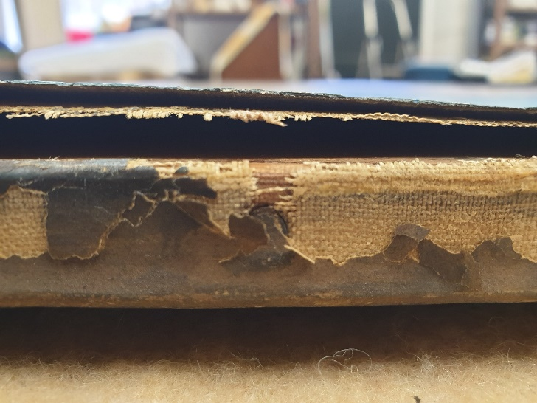
Support: the primary support is an artists' linen canvas. The canvas has been 'glue lined' in the past and has a second layer of linen fabric adhered to the back of original canvas with an animal glue. The original tacking/turnover edges have been removed. The canvas layers are in a poor condition. The animal glue adhesive is dry, brittle and has started to fail. It no longer bonds the two layers of canvas together and is delaminating. This is most noticeable around the edges of the painting. The lining canvas edges have dramatically split around the whole of the top edge and also sections down the vertical sides, beginning at the top right and left corners. The stability of the canvas support is completely compromised. There is no longer any tension across the surface of the canvas layers and the surface plane is cockled and distorted. As the painting has be stored horizontally on a table top it is sagging under its own weight. There is also an old repaired tear towards the centre of the top edge. The old damage is supported by a canvas patch, which has been adhered to the reverse. On the front of the painting it is disguised with filler and retouching. On the back of the painting it is the reverse of the lining canvas that can be seen. This canvas is very dirty and has many dots, splashes and accretions. There is a thick layer of accumulated dirt that has become trapped between the stretcher and the canvas. The broken lining canvas threads around the edges of the painting are very brittle and can be crumbled to dust if rolled between your fingers.
Split in the lining canvas top edge of painting
Split and delamination along top edge

Paint and Ground: The paint and ground layers are in a poor condition. There is loose and fragile paint adjacent to all of the torn canvas edges. Some sections of original paint around the edge is being held in place and supported with layers of overpaint from a previous restoration. As the painting is lying horizontally on a table the sagging of the canvas is putting pressure on the ground and paint layers.

There are numerous areas of old retouching on the paint layer. The most noticeable are in the deep blue of the sky, along the top edge. The patch in the canvas layers in the centre of the top edge is also filled and disguised. The retouching has slightly changed colour but is hard to spot in the wide expanse of bright blue sky. In the light from a hand-held UV torch some lines that strengthen the figures could be seen fluorescing as dark patches. Just how much overpaint has been applied to the painting can only be quantified in studio conditions with powerful UV Lamps. There is no overall network of age crack or signs of drying cracks.
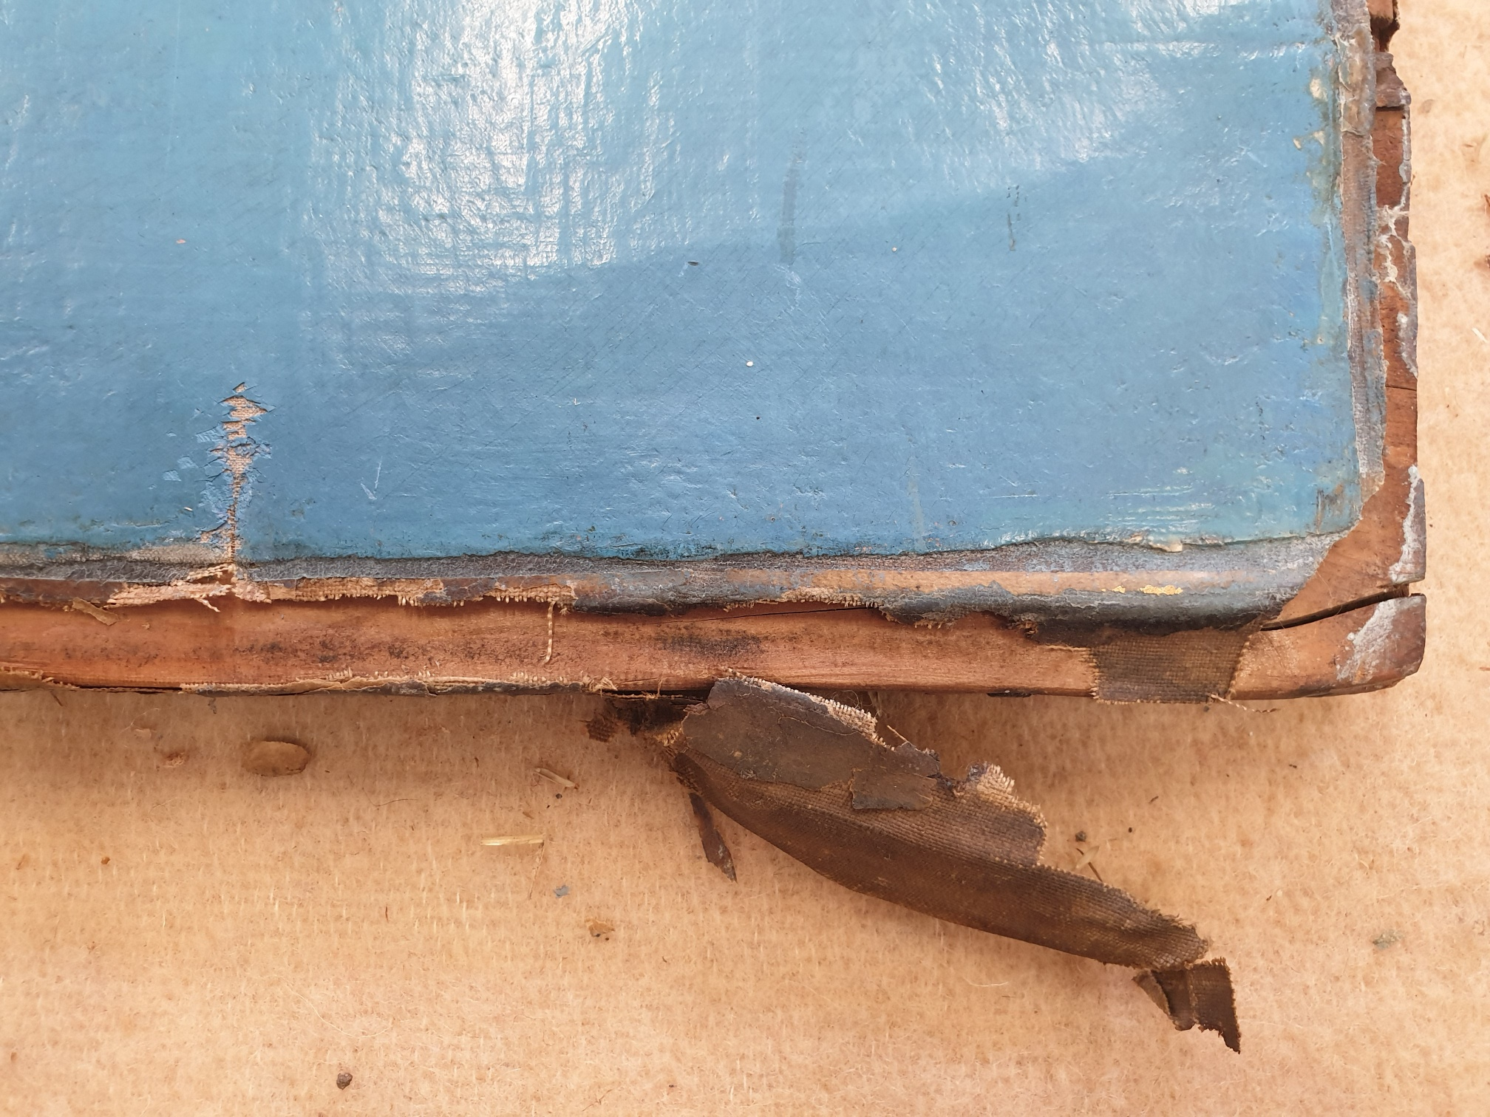
Upper right corner showing overpaint, damaged original paint, split in the stretcher and broken edge canvas.

Varnish and Surface Dirt: There is a grey surface dirt layer resting on top of the shiny thick varnish layer. The varnish is fairly evenly applied and still has a high surface gloss. It appears to be an older natural resin varnish and not a modern synthetic type. The varnish does not have its own network of cracks.

Recommended Treatment
The painting requires major treatment. It cannot be displayed in its present condition and it is difficult to store. The frame requires joinery work to make it fit for purpose again.

Written and photographic documentation will accompany the conservation treatment.

- Pack the painting on site to safely transport it to the studio.

- Examine the paint surface and re-attach any flaking of the paint and ground with either isinglass or another suitable adhesive.

- Remove the remaining tacks from the lining canvas edges and remove the painting from the stretcher.

- Face the whole painting with lens tissue and a 15% solution of Beva 371 adhesive dissolved in white spirit.

- Turn the painting over and remove the lining canvas and glue-paste layer.

- Eliminate the surface deformations in the support by applying moisture to the back of the canvas and weighting under blotting paper. Alternatively, pre-stretch the canvas with brown paper margins on a wooden loom.

- ‘Line’ the painting onto polyester sailcloth with Beva 371 adhesive film.

- Clean and polish the original stretcher and attach a loose, cosmetic, linen backing.

- ‘Tie in’ the original tensioning wedges and the originals with nylon wire, cups and screws.

- Re-attach the lined painting onto the stretcher with stainless steel or copper tacks.

- Remove the facing/lens tissue.

- Test the surface dirt, varnish and overpaint lavers for solubility.

- Remove the surface dirt and varnish layers.

- Remove as much of the crude overpaint as is deemed viable.

- Fill the losses in the paint and ground layers with an inert filler.

- Apply an isolating layer of Paraloid B72 varnish.

- In-paint all losses and abrasions with dry artists’ pigments bound in Paraloid B72 as the medium

- Apply a final protective/aesthetic varnish coating of MS2A resin, modified with Cosmolloid 80H microcrystalline wax to alter the surface gloss.

- Repair the frame by re-gluing and clamping the corner joints.

- Repair and retouch the front face and edges of the frame with suitable materials to disguise any damages to the frame finish.

- Add a new build-up. Slip and acrylic glazing and backboard to the frame.

- Reframe the painting within a cushioned rebate with brass framing strips

Estimate for Full conservation

Conservation Hours: | £4,000.00 | £4,000.00 | £4,000.00
Joinery: | £237.00 | £237.00 | £237.00
Glazing Options:  Standard acrylic | £150.00
UV Acrylic: |  | £300.00
Optium Museum  Acrylic |  |  | £670.00
TOTAL: | £4387.00 + VAT | £ 4537.00 + VAT | £ 4907.00 + VAT

Please note there is no figure above for collection and delivery back to the museum.
This would be approximately £300,00 + VAT

Conservator: Phillip Bourne |  |  | Date: 14th September 2019
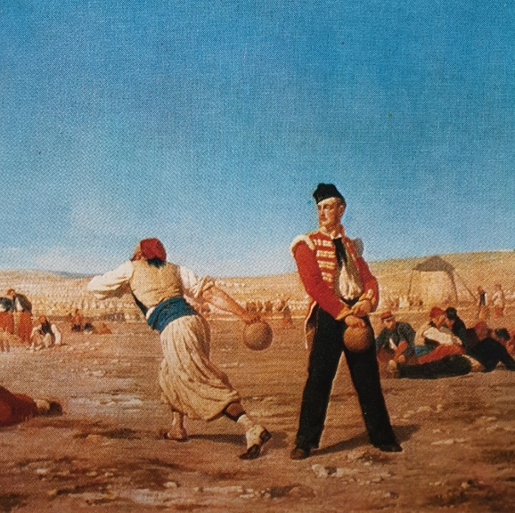CMML Image

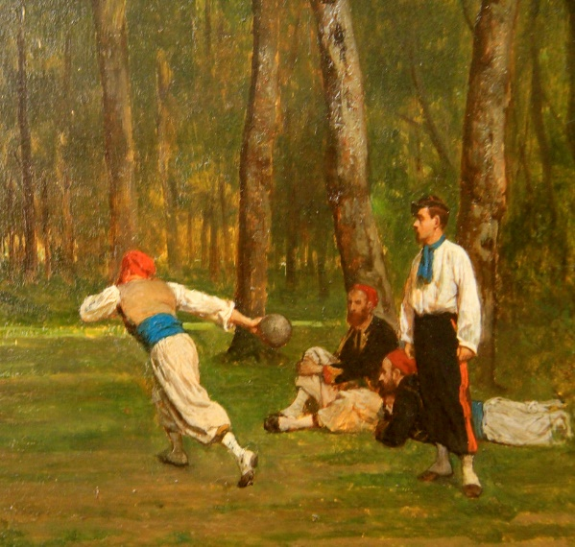Protais using same figure in another painting in the Musee de Grenoble

